Site Surveying & Set Out 1

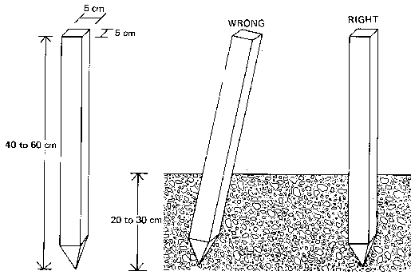
Pegs
Pegs are used when certain points on the field require more permanent marking. Pegs are generally made of wood; sometimes pieces of tree-branches, properly sharpened, are good enough. The size of the pegs (40 to 60 cm) depends on the type of survey work they are used for and the type of soil they have to be driven in. The pegs should be driven vertically into the soil and the top should be clearly visible.
Fig. 1 Pegs
(ARRAH PEGS. 50mm x 50mm x 150mm White Topped. 50mm x 50mm x 225mm White Topped)
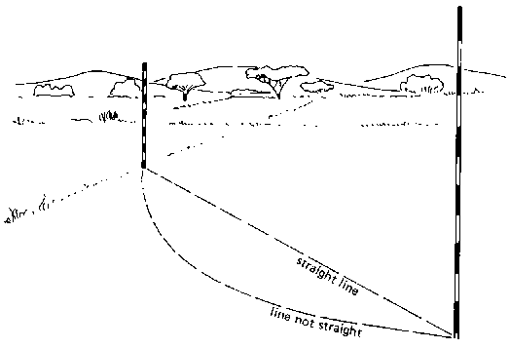

Definition of a Straight Line
A straight line is the shortest distance between two points on a map or between two points on the field (see Fig, 1).
Fig. 2 straight line

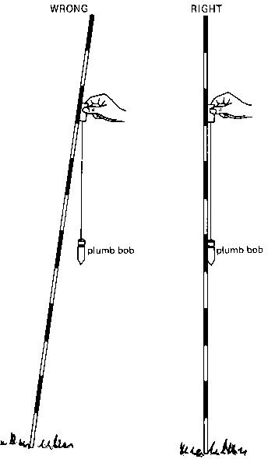
Ranging Poles
Ranging poles (see Fig. 7) are used to mark areas and to set out straight lines on the field. They are also used to mark points which must be seen from a distance, in which case a flag may be attached to improve the visibility.
Ranging poles are straight round stalks, 3 to 4 cm thick and about 2 m long. They are made of wood or metal. Ranging poles can also be home made from strong straight bamboo or tree branches.
REMEMBER: Ranging poles may never be curved.
Ranging poles are usually painted with alternate red-white or black-white bands. If possible, wooden ranging poles are reinforced at the bottom end by metal points.

Measuring Short Distances
The following procedure is used when measuring a distance which does not exceed the total length of the chain or the tape.
Step 1
Pegs are placed to mark the beginning and the end of the distance to be measured.
Step 2
The back man holds the zero point of the chain (or tape) at the centre of the starting peg.
The front man drags his end of the chain (or tape) in the direction of the second peg. Before measuring, the chain (or tape) is pulled straight (see Fig. 15).

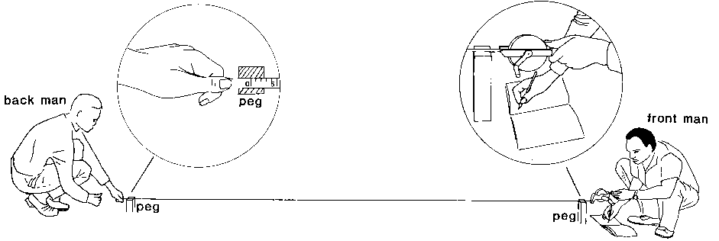

Any knots in the tape or entangled links in the chain result in errors in the measurement,
Step 3
When using a measuring tape, the distance between the two pegs can be read directly on the tape by the front man.
When using a chain, the number of links between the two pegs is counted. The total distance is equal to the number of links multiplied by the length of one link (20 cm).
Distance = number of links x length of one link
EXAMPLE: Calculate the distance when given that 30 links have been counted and the length of one link = 0.2 m.
ANSWER: Distance = number of links x length of one link = 30 x 0.2 = 6 m

Measuring Distances in Tall Vegetation
Distances may have to be measured in a field where a tall crop or tall grass is cultivated. The measuring tape (a chain would be too heavy) must then be stretched horizontally by the two men above the crop.
When measuring distances it is important to keep the tape horizontal. Push two arrows or two pegs into the soil to mark the distance to be measured (see Fig. 17). Plumb bobs can be used to check if the measuring tape is indeed horizontal. If horizontal, the free hanging plumb bobs (immediately above the arrows) are perpendicular to the measuring tape. In other words, the measuring tape and the plumb bobs form right angles.
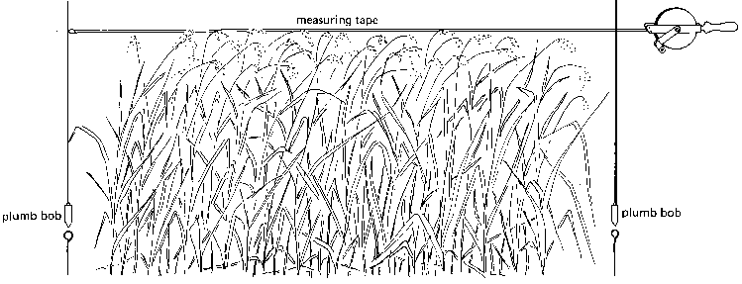

Setting out a right angle
Three persons hold the tape the way it has been explained above. The first person holds the zero mark of the tape together with the 12 m mark on top of peg (C). The second person holds the 3 m mark in line with pole (A) and peg (C), on the base line. The third person holds the 8 m mark and, after stretching the tape, he places a peg at point (D). The angle between the line connecting peg (C) and peg (D) and the base line is a right angle (see Fig. 21b). Line CD can be extended by sighting ranging poles.
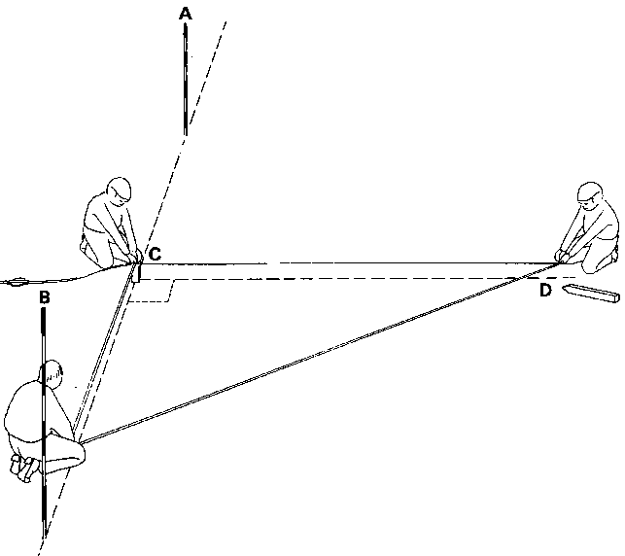

Using an optical square

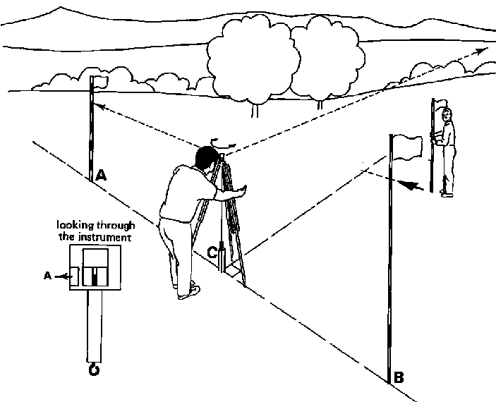
Field with an irregular shape of which the surface area must be determined.
The procedure to follow is:
Step 1
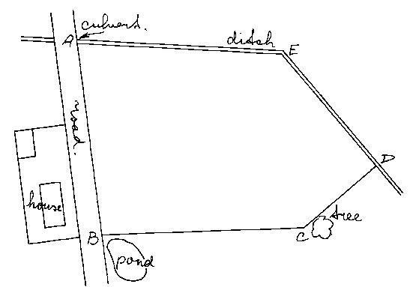
Make a rough sketch of the field (see Fig. 29a) indicating the corners of the field (A, B, C, D and E) and the field borders (straight lines). In addition some major landmark! are indicated (roads, ditches, houses, trees, etc.) that may help to locate the field.
Step 2
Divide the field, as indicated on the sketch, into areas with regular shapes. In this example, the field can be divided into 3 triangles ABC (base AC and height BB,), AEC (base AC and height EE₁) and CDE (base EC and height DD₁) (see Fig. 29b).
Fig. 29a A rough sketch of the field
Step 3
Mark, on the field, the corners A, B, C, D and E with pegs.
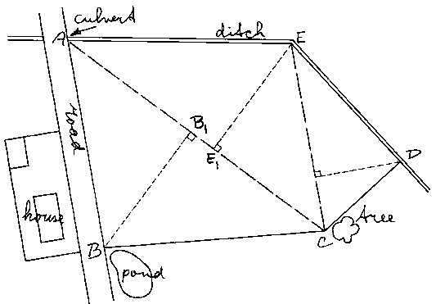
Step 4
Set out ranging poles on lines AC (base of triangles ABC and AEC) and EC (base of triangle EDC) (see Fig. 29c) and measure the distances of AC and EC.
Boning rods are T-shaped and made of wood. Their height is normally 100 cm and the cross-lath is 50 cm x 10 cm. The bottom part is sometimes reinforced with metal (see Fig. 34).
Fig. 29b Division of the field into areas with regular shapes
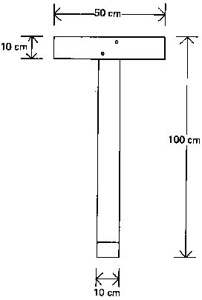
Boning rod

It is important that all boning rods have exactly the same height (100 cm) and while working with the boning rods, the sun should be kept in the back, as it would otherwise be difficult to see them. Usually a total of 3 or 4 boning rods is required.

Use of boning rods

"Australian Height Datum” means the datum of mean sea level as determined by the National Levelling adjustment in 1971 and adopted by
the National Mapping Council of Australia at its 29th meeting as the datum to which all vertical control for mapping is to be referred;

"Map Grid of Australia 1994 (MGA 1994)"
means the system of rectangular co-ordinates derived from a Universal Transverse Mercator projection of Geocentric Datum of Australia 1994 (GDA) latitudes and longitudes that are based on the datum (GDA) defined in the notice of the Inter- Governmental Committee on Surveying and Mapping published in Commonwealth Government Gazette Number GN 35 of September 1995 at page 3369;

